WMS in Metamod

Components
A functional overview of WMS operations, using CryoClim as example:
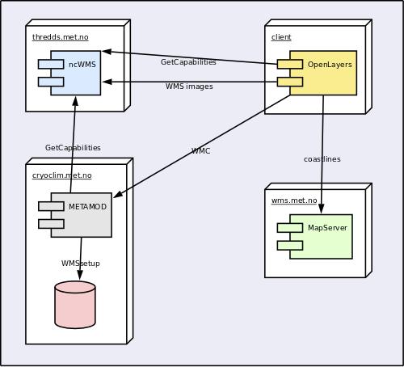WMS operations in Metamod
http://dev-vm140/Metamod2.x/sch/wms.php?wmssetup=http%3A%2F%2Fdev%2dvm140%2FMetamod2.x%2Fsch%2FgetWMSSetup%3FdatasetName%3DH2x%2Fice%2Fice_conc_nh_200910191200_CF

WMS Client
OpenLayers - JavaScript client for web. Uses extended WMC support library developed by met.no.
http://openlayers.org/

WMS Server
NcWMS - integrated with THREDDS. Cannot render shapes, only grids.
http://www.resc.rdg.ac.uk/trac/ncWMS/
MapServer - used on wms.met.no for displaying coastlines
http://mapserver.org/

METAMOD WMC generator
Perl proxy/web service. Merges GetCapabilities and WMSsetup file using XSLT. Also works as proxy to get around security limitations in JavaScript.

Protocols and formats

WMS
The OpenGIS® Web Map Service Interface Standard (WMS) provides a simple HTTP interface for requesting geo-registered map images from one or more distributed geospatial databases. A WMS request defines the geographic layer(s) and area of interest to be processed. The response to the request is one or more geo-registered map images (returned as JPEG, PNG, etc) that can be displayed in a browser application.
http://www.opengeospatial.org/standards/wms

WMS example
http://thredds.met.no/thredds/wms/cryoclim/met.no/osisaf-sh/osisaf-sh_aggregated_ice_concentration_sh_polstere-100_198707010000.nc?VERSION=1.1.1&FORMAT=image%2Fpng&STYLES=BOXFILL%2Frainbow&LAYERS=ice_conc_avg&SERVICE=WMS&REQUEST=GetMap&EXCEPTIONS=application%2Fvnd.ogc.se_inimage&SRS=EPSG%3A32761&BBOX=-900000,-900000,5000000,5000000&WIDTH=256&HEIGHT=256

GetCapabilities
XML document describing all available layers and styles in a single data file. Lacks projection and bounding box info.
http://webhelp.esri.com/arcims/9.2/general/mergedProjects/wms_connect/wms_connector/get_capabilities.htm

Example Capabilities document
http://thredds.met.no/thredds/wms/cryoclim/met.no/osisaf-sh/osisaf-sh_aggregated_ice_concentration_sh_polstere-100_198707010000.nc?service=WMS&version=1.3.0&request=GetCapabilities

Web Map Context
XML document specifying desired presentation in client. Can merge layers from different sources, with only desired layers and corresponding styles.
http://www.opengeospatial.org/standards/wmc

Example WMC document
(currently not deployed outside Met.no firewall)
http://dev-vm140/cgi-bin/gc2wmc.pl?setup=http%3A%2F%2Fdev-vm140.oslo.dnmi.no%2FMetamod2.x%2Fsch%2FgetWMSSetup.php%3FdatasetName%3DH2x%2Fice%2Fice_conc_nh_200910161200_CF

