Tseries Screenshots

The Tseries GUI
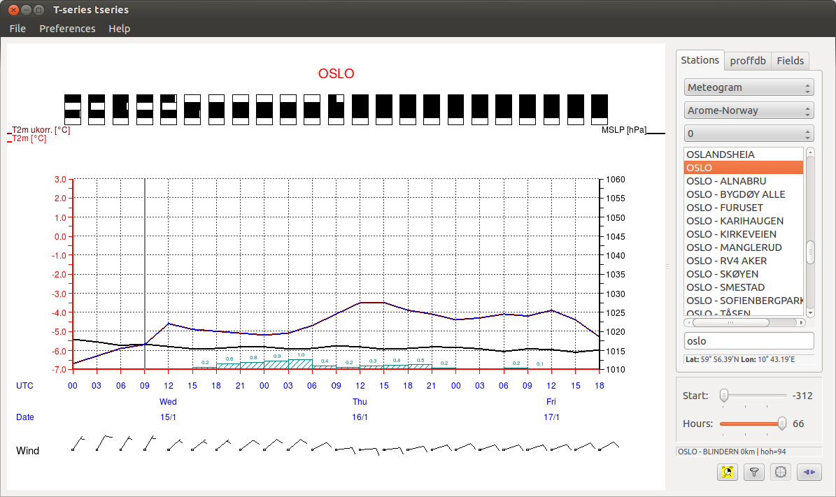

Example Diagrams

Meteogram

With weather symbols
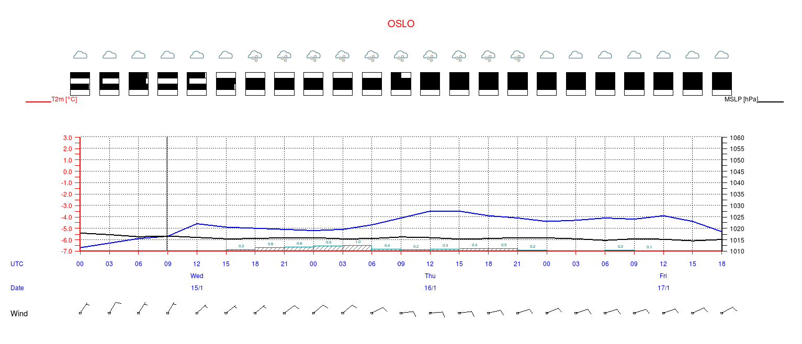

With Observations
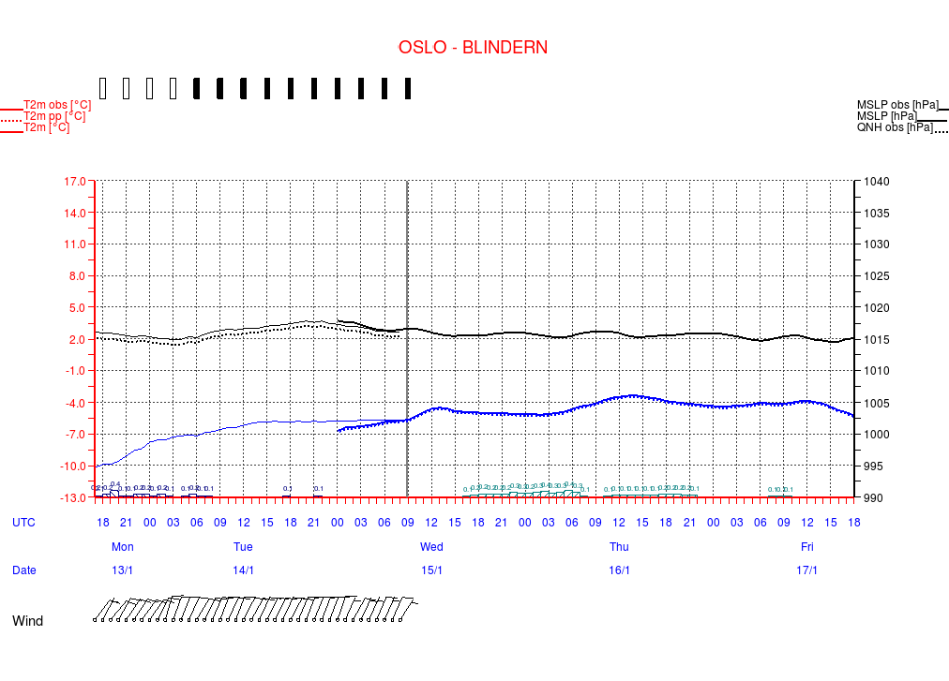

With long term Observations
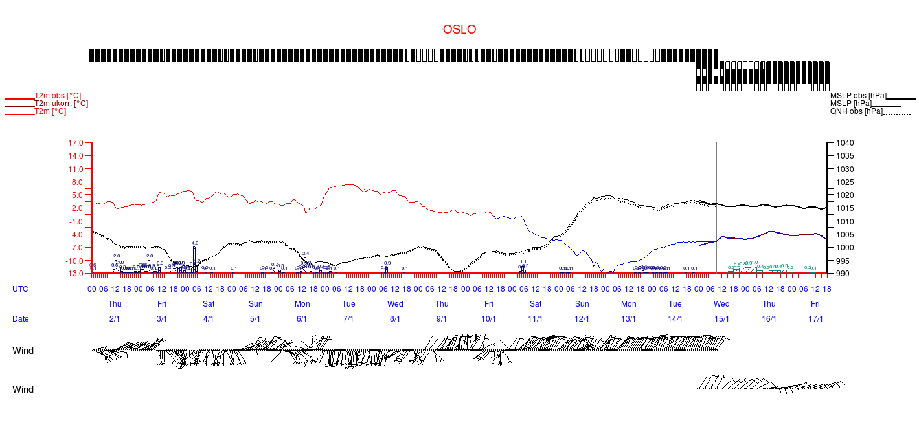

Ensemble prediction

Smoke-plums for Temperature
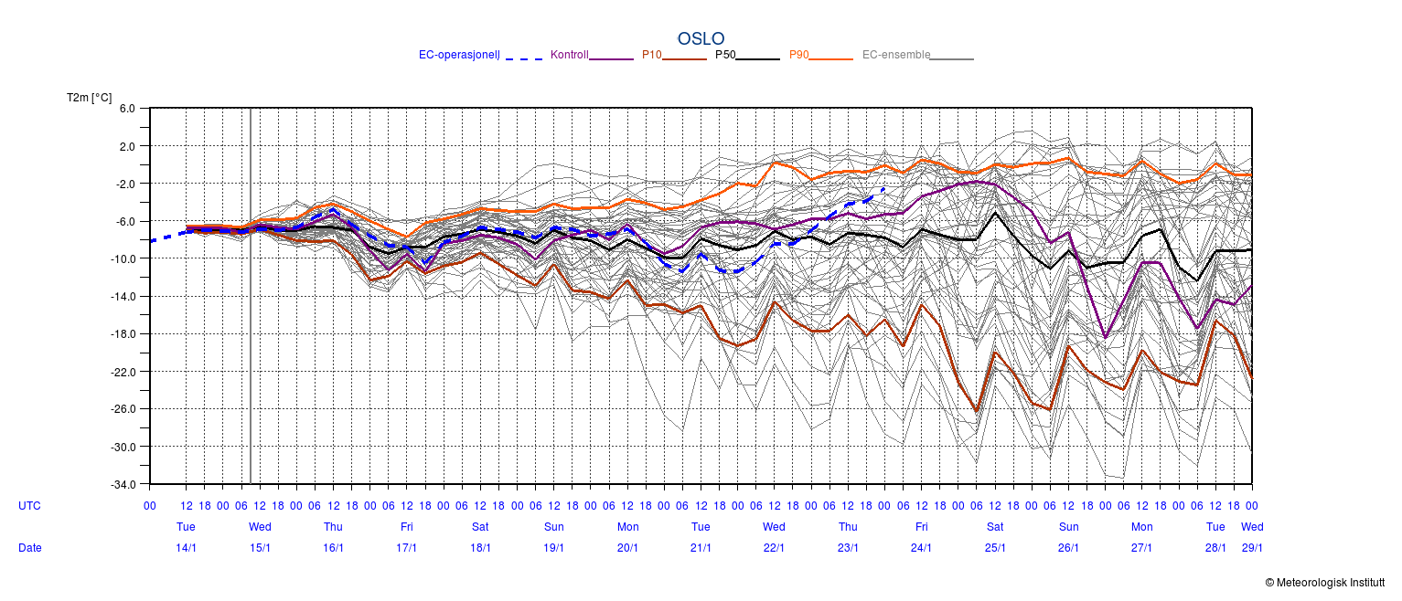

ACCUMPRECIP

Accummulated Precipitation
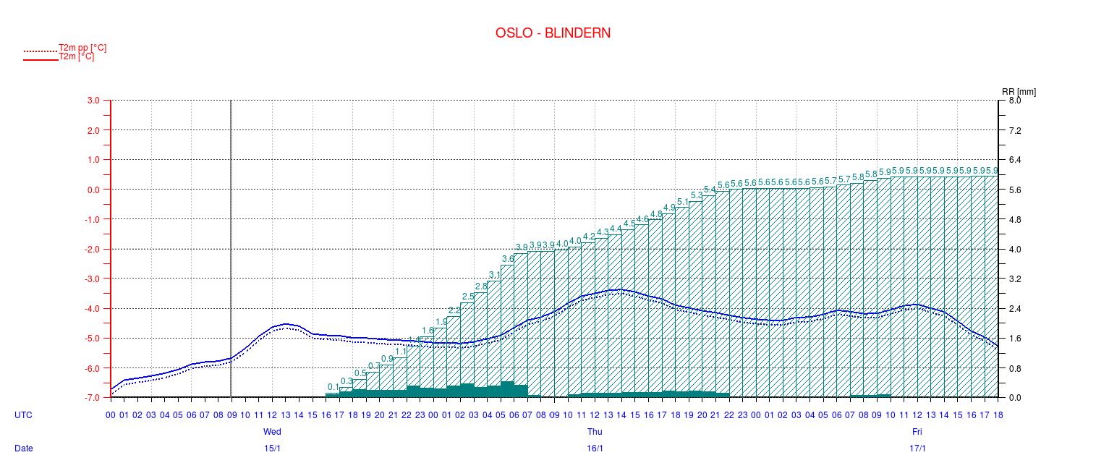

Multi Diagram

Several Diagrams in one Product


