Simple online sharing

Share data online
For simple data sharing, use the script /projects/NS2345K/tools/wwwpublish:
Usage:
wwwpublish <absolute path to data directory> <dataset name>
or
wwwpublish <absolute path to data file> <dataset name>
Example:
wwwpublish /projects/NS2345K/noresm/thredds/CORE2/AMOC CORE2-AMOC
or
wwwpublish /projects/NS2345K/noresm/noresm2cmor.tbz noresm2cmor
Purpose:
Publish data online at http://ns2345k.web.nird.no
Description:
The input path must be absolute and start with /projects/NS2345K.
Only regular files are considered. Symbolic links are skipped.
All date files must have unique names as the folder stucture is
flattened during publication.
Reading permissions of the data files have to be open to everyone.
However, reading permissions of the folders containing the files
can be closed.
<dataset name> should be one word and not contain any special
characters other than "-" and "_".
The script provides following:
- local path to a folder that contains hard-links to the data files
- URL that points to the online-catalogue where the shared files are exposed
- download-URL to a wget-script that can be used to download the entire dataset (note that execution permissions have to be changed prior to running the script)
NOTE: The sharing method uses hard-links. This has the advantages that no additional disk space is used and that the sharing happens instantaneous. A removal of the hard-links will unshare the data, but will not affect the original files.

Unshare data
If you don't want to share a dataset anymore, use the script /projects/NS2345K/tools/wwwunpublish:
Usage: wwwunpublish <dataset name>
Example: wwwunpublish CORE2-AMOC
Purpose: Unpublish a dataset from NorStore's www-server
NOTE: Unsharing data will not affect the original data.

Data sharing via the Norwegian ESG data portal

IMPORTANT: The portal is currently offline for maintenance and its operation is expected to be resumed sometime in October. For an alternative data sharing method see previous section "Simple data sharing".
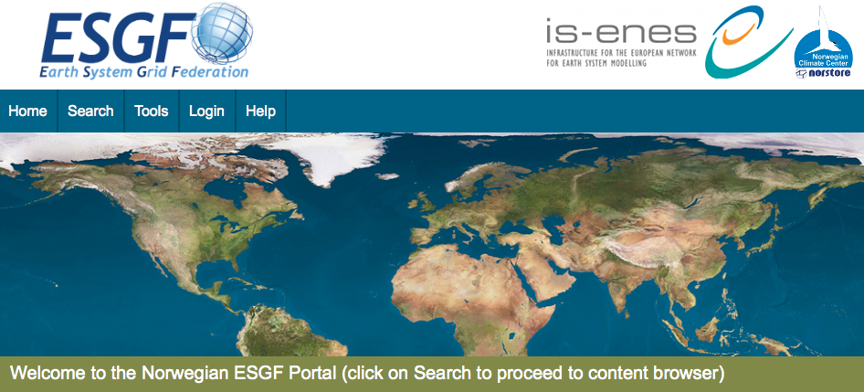

Simplified publishing (unofficial ESG publication)
All users of the NorStore project ns2345k have the possibility to share their data via NorStore's ESG data portal http://noresg.norstore.no.
Requirements are:
- the data has to reside in /projects/NS2345K (same as /norstore_osl/projects/NS2345K)
- all files must be regular (i.e., no symbolic links)
- file names must all be unique (folder hierarchy is flattened during publication)
- reading permissions of data files must be open to everyone (does not apply to their parent folders)
Note that the data sharing solution uses hard links to avoid additional use of disk resources. The original data is not touched/modified.

Publish a simple dataset to NorStore's ESG data portal
For simple data sharing with ESG support, use the script /projects/NS2345K/tools/esgpublish:
Usage: esgpublish <absolute path to data directory> <dataset name> [unlisted]
or
esgpublish <absolute path to data file> <dataset name> [unlisted]
Example: esgpublish /projects/NS2345K/noresm/thredds/CORE2/AMOC CORE2-AMOC
or
esgpublish /projects/NS2345K/noresm/noresm2cmor.tbz noresm2cmor unlisted
Purpose: Publish data via NorStore's online data portal http://noresg.norstore.no
Description: The input path must be absolute and start with /projects/NS2345K or
/norstore_osl/projects/NS2345K.
Only regular files (i.e., no symbolic links) are considered.
All date files must have unique names as the folder stucture is
flattened during publication.
Reading permissions of the data files have to be open to everyone,
but reading permissions of the folders containing the files can be
closed.
<dataset name> should be one word and not contain any special
characters other than "-" and "_".
If a third argument is specified and set to "unlisted" then the
dataset will be served through the file server but not published
to the portal.

Remove a simple dataset from NorStore's ESG data portal
To unpublish a dataset that previously has been published with esgpublish, use the script /projects/NS2345K/tools/esgunpublish:
Usage: esgunpublish <dataset name>
Example: esgunpublish CORE2-AMOC
Purpose: Unpublish a dataset from NorStore's online data portal http://noresg.norstore.no

Standard publishing (official ESG publication)
Several projects (e.g, CMIP, GeoMIP, etc) require special post-processing and ESG publishing procedures.
Please contact Ingo Bethke (ingo.bethke[at]uni.no) or Alf Grini (alfg[at]met.no) for assistance.

