

METAMOD 2.x
During 2001/2002, the Norwegian Meteorological Institute (METNO) implemented a web based tool (MetaMod) for searching data archived under the NoSerC project (http://noserc.met.no/). This tool was adapted for the DAMOCLES project in 2006/2007. The web interface and the overall functionality of the tool were very much improved during the DAMOCLES development, and just a small part of the original code base has remained unchanged. Other projects at METNO have also contributed to the development process. The software is now named METAMOD 2.x, to distinguish it from the original MetaMod tool that is still occasionally maintained.
METAMOD 2.x is a portal solution providing Discovery, Access and Retrieve functionality for scientific datasets along with tools for metadata handling etc. Further development of the software is now coordinated with other developement efforts at METNO (e.g Fimex), within the METSIS project. In the figure below, METAMOD 2.x represents the web portal and metadata database within the wider framework of METSIS:
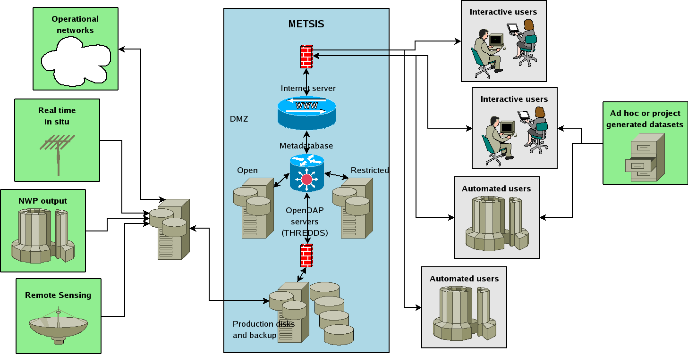Outline of how METAMOD is being used.
The purpose of the METAMOD 2.x software is threefold:
- To manage a local data repository with scientific data files.
- To manage a database with metadata for scientific data sets. Data sets are collections of data files, either in the local repository, or in external repositories.
- To provide a web portal for searching and browsing the metadata database.
As additional projects were seen to benefit from using METAMOD 2.x software, a need for making the software independent of a single project emerged. This was obtained by organizing the software in different modules, and by separating all project specific aspects into a configuration file. METAMOD 2.x now comprise the following modules:
METAMODBASE | Metadata database and corresponding administrative tools.
METAMODSEARCH | Web based search and browsing facility.
METAMODUPLOAD | Web based upload facility for data files.
METAMODQUEST | Web based questionnaire for registering metadata.
The configuration file describes an actual implementation of a web application based on METAMOD 2.x software. First of all, the file lists which of the four modules that are used in the application. Any combination of the four modules is allowed. If the METAMODBASE module is not a part of an application, the configuration file must identify a database owned by another application where the METAMODBASE module is used. In this way, several applications may share the same database.
The software is implemented on a Linux system with Apache web server. PHP is used to implement dynamic web content, and Perl is used to implement tasks not directly involving web content generation. The database is based on PostgreSQL. Metadata elements use controlled vocabularies from GCMD and CF1.0 as well as WMO keywords. Tools for extracting metadata from NetCDF/CF files are part of METAMODUPLOAD. Access to the actual data files are provided as links from the web pages generated by the METAMODSEARCH module.
The local data repository is an ordinary file system where files are orginized in catalogs according to institutions (data providers) and data sets. The catalogs and files must be accessible through URLs. This can be done using HTTP, FTP, OPeNDAP or a combination of these protocols. The DAMOCLES application use a THREDDS Data Server (giving OPeNDAP access), as well as HTTP (Apache) and FTP servers. If the data files satisfy OGC standards, THREDDS may also provide OGC WCS access.
Metadata exchange with other metadata centers, based on the OAI-PMH protocol, will soon be implemented in METAMOD 2.x.

News

2008-06-20
METAMOD 2.0.0 released

2008-12-19
METAMOD 2.1.0 released

