Overview of METAMOD
METAMOD is a software system for searching and browsing a repository of metadata for scientific datasets. It consists of a database of metadata, a web interface for searching and browsing metadata and a machine interface that can be used to automatic retrieval of metadata by other metadata repositories.
METAMOD can retrieve metadata from different sources:
- Automatically extracted from netCDF files that are uploaded to the system either manually or automatically.
- Manually added through customizable questionnaires.
- Harvested from other metadata sources via the OAI-PMH standard.
The figure below shows how METAMOD is used to extract, validate and store metadata from different sources. The metadata is then made available to either a human user via the web interface or to other machines via the machine-machine interface. By storing metadata from different sources in the same metadata repository, METAMOD unifies the data available from different sources to simplify finding the desired metadata and associated datasets. An important feature of METAMOD is that it understands several different metadata formats and can convert between the different formats. Currently the following metadata formats are supported: ISO19115/19139, DIF, DC and MM2
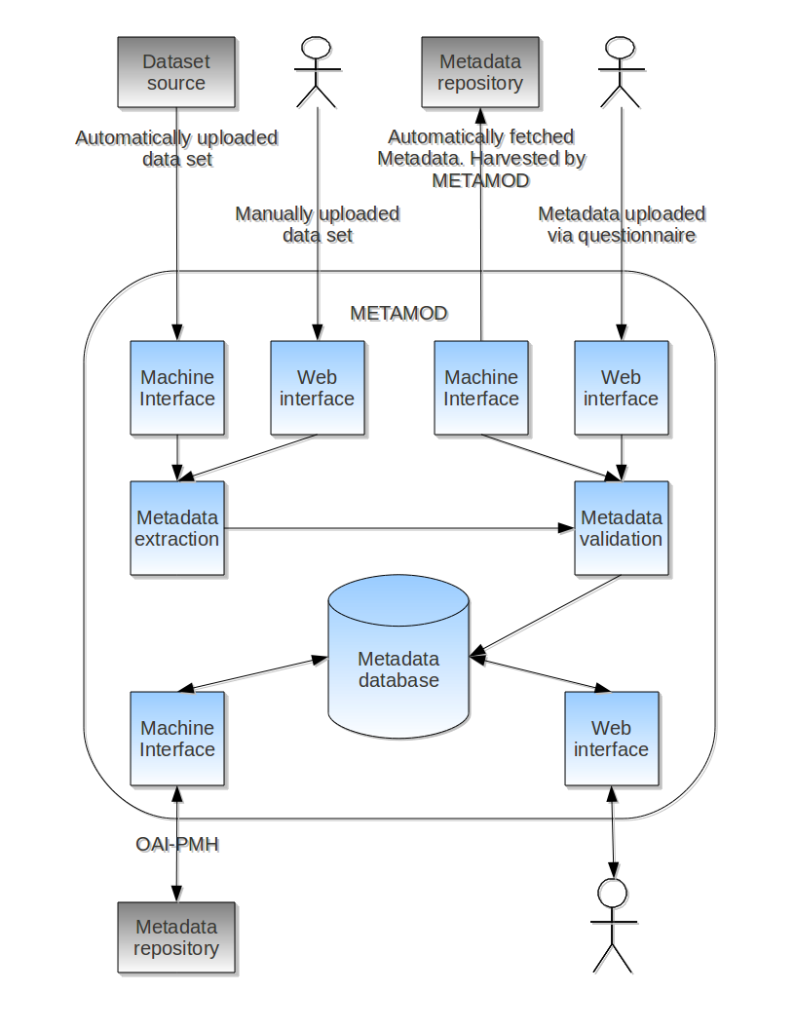
In addition to offering a repository of metadata it is possible to extend the functionality of METAMOD by intergrating it with other systems.
- Intergration with the THREDDS Data Server to offer downloading of data sets either via HTTP, OpenDAP, CSW or WMS.
- On the fly interpolation of data before download using the Fimex library
- Web interface for data visualization using OpenLayers (requires WMS server on data-repository)

Example: Metamod and Thredds
The figure below shows the different components of METAMOD example installation. In the example installation data sets have been upload to a local dataset repository stored on the fileystem of a server. The data sets are offered for download via a THREDDS Data Server.
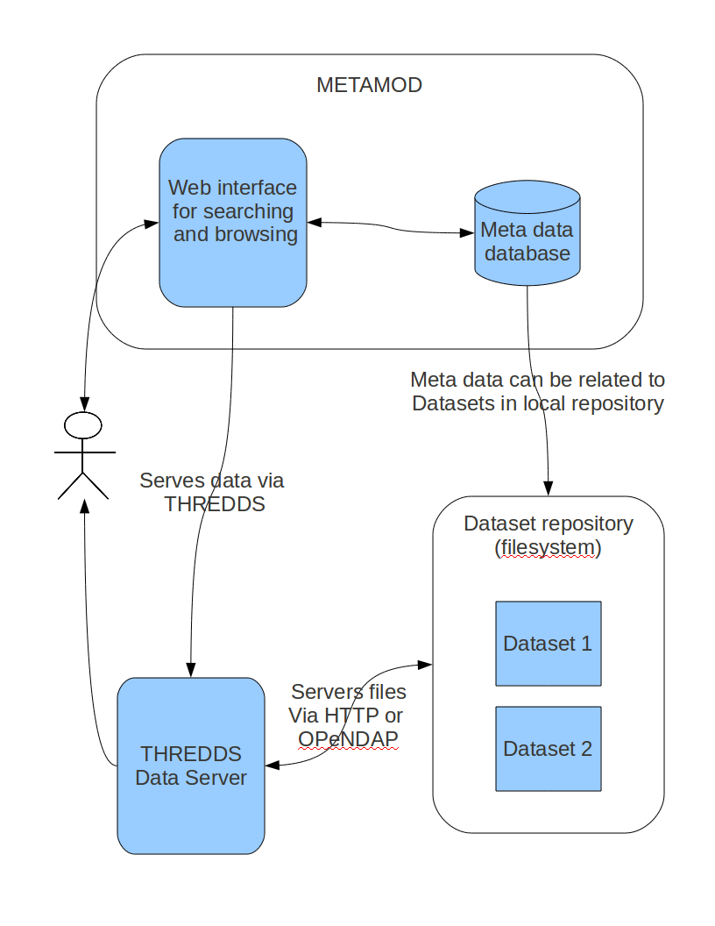

Projects currently using METAMOD
The following projects use METAMOD today:
- http://cryoclim.met.no/metamod/sch/
- http://damocles.met.no/r1/sch/
- http://dokipy.met.no/r1/sch/

