kilden oil spill forecast order form, with input from ship drift
In this case, the user has hit the Get ship trajectory button in stead of entering the positions and times manually. The ship drift data are selected from a pop-up window (shown below). Note that the position/time data shown in the order form are now a series of data points. These may be edited manually, e.g., in order to vary the leakage rate with time.
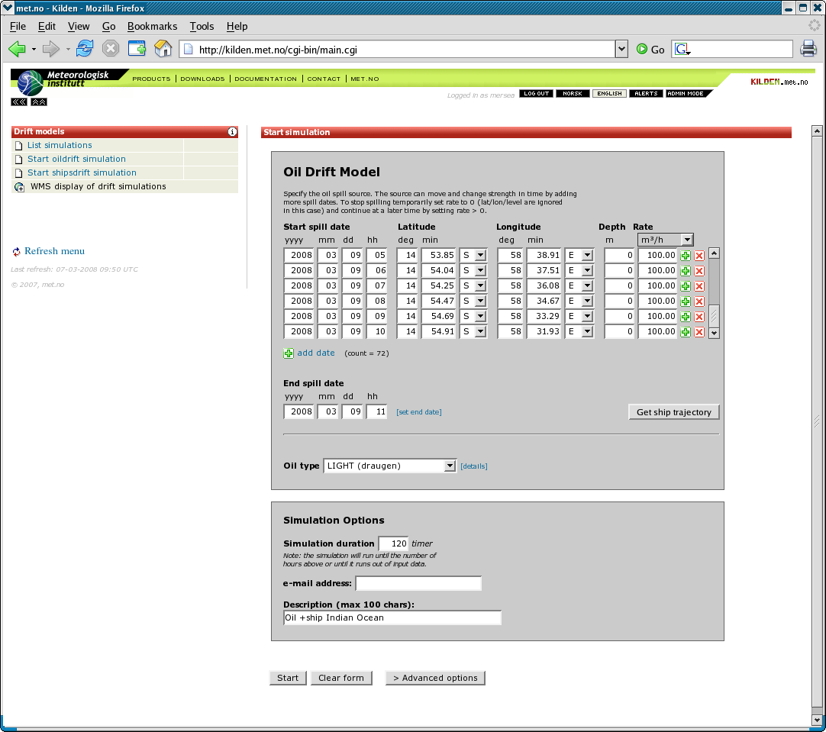kilden oil+ship order form
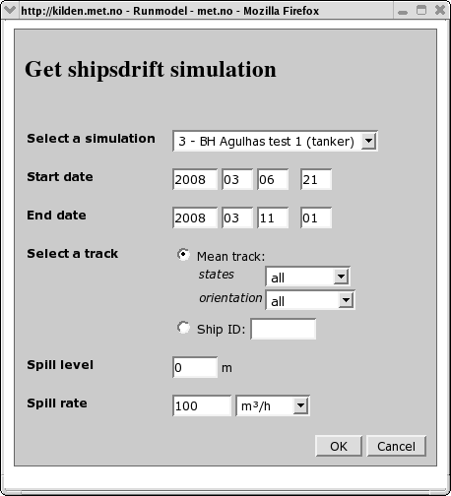kilden oil+ship selectship

