kilden ship drift forecast order form
Main menu is always at left.
Ship drift forecast order form is in the main panel at right.
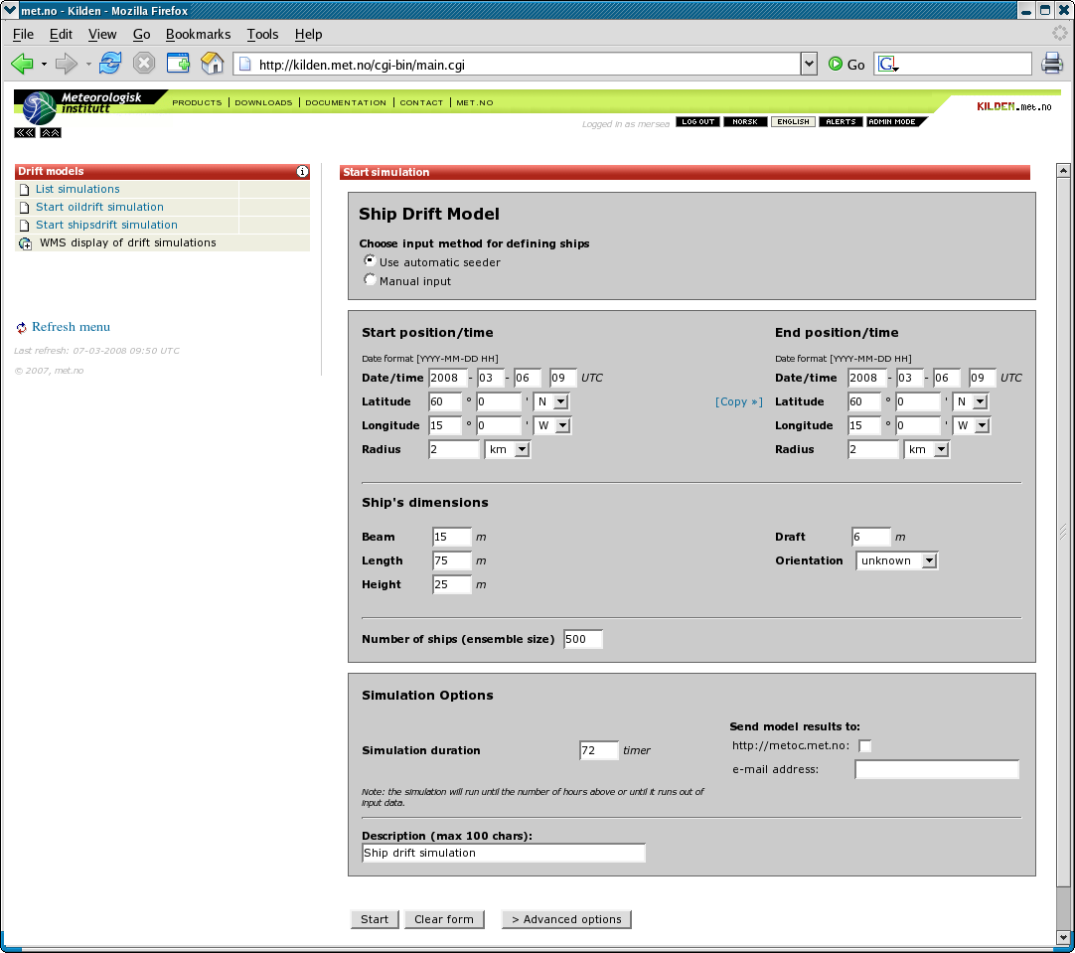screenshot_kilden_mersea_oil_order.png|kilden drift services : ship drift order form

