kilden oil drift forecast order form
Main menu is always at left.
Oil spill forecast order form is in the main panel at right.
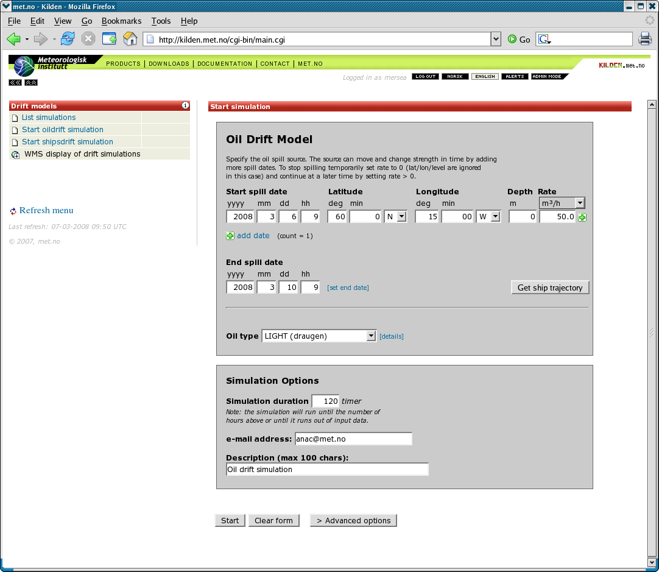kilden drift services : oil drift order form

