Qc2 Scientific Tasks

Verification/Case Analysis of the redistribution of the accumulated precipitation Qc2 algorithm
Original testing was carried out for data obtained between March 2007 and December 2007 giving rise to a comparison to real observations with simulated test data (constructed from real observations): | 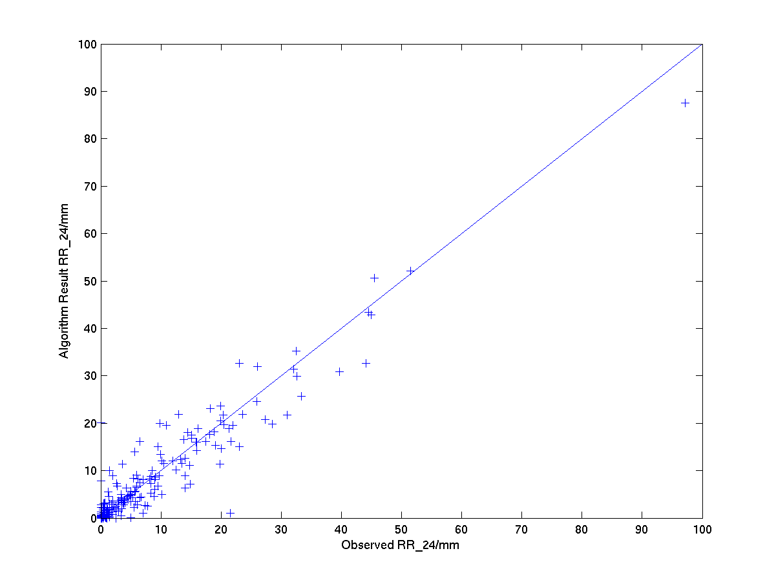
... as well as a comparison to the results of HQC: | 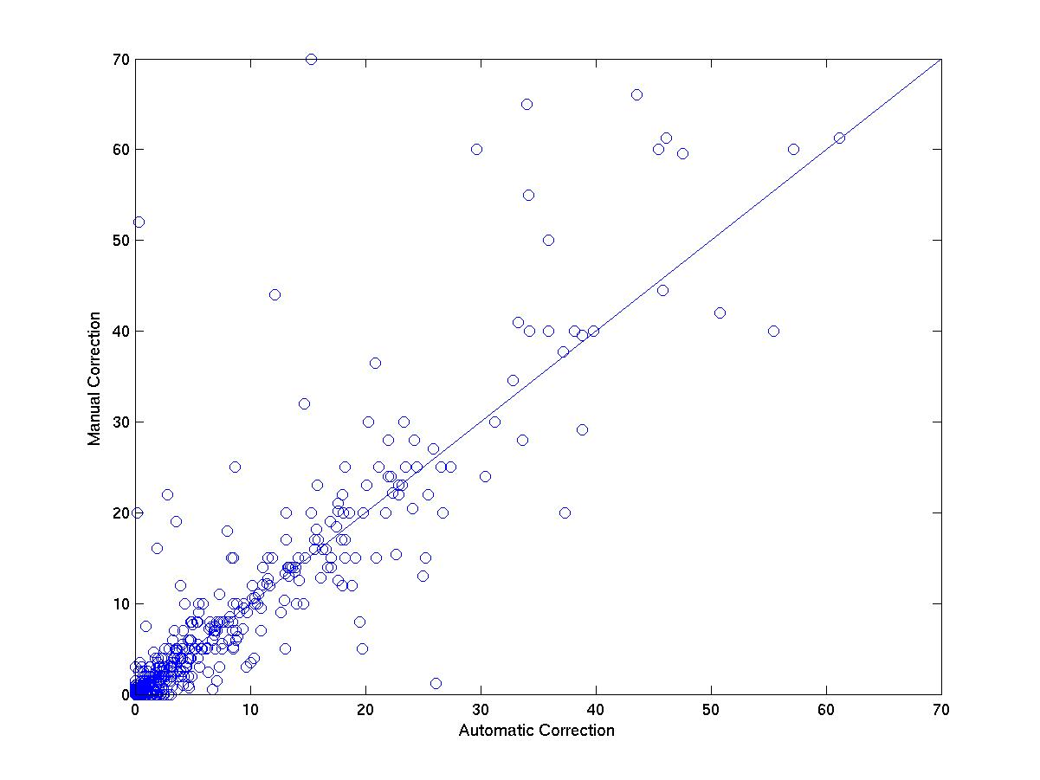
Short Term Tasks
Action | Resposnsible | Due Date
Build tool (with documentation) that for a given interval will automatically generate test data by computing accumulations to allow fast analysis on the virtual test machine | IT-gruppa/PE | 20091231
Identify scenarios for testing the algorithm: e.g. convective vs frontal precipiation systems, specific regions in Norway. Also tests cases that compare all dry or all wet with mixed etc. | SKF | 20100118
Run Tests (NB incorporate some cases into the Acceptance Test File) Write test report. | IT-gruppa/PE | 20100124
Analysis of results and make recommendation for Qc2 RARR_24 Operational Deployment, include a consideration of optimal interpolation method taking into account the balance with the number of corrections obtained (i.e. if a model value is computed sometimes depends on the interpolation method chosen and if the required set of neighbours exists). The recommendation shall also stipulate decisions like only applying to all wet or all dry conditions, height normalisation etc. | All | 20100207
-oOo- | -oOo- | -oOo-
The action deadlines above provide scheduling for completion of each task. Actual hours requested from SKF (for the identification of scenarios, analysis of results, iteration on testing and recommendations: 2 weeks.

Other Short Term Tasks
Task | Estimate of human-hours
Specification of a Qc2 guideline document. | -
Identification of parameters to include in spatial checks (e.g. monthly averages, normals etc. For use in comparisons. | 0.5 weeks
Specification of rules to follow in performing interpolation (preferred methods, number of points) | 0.5 weeks
Identification of proxies that may be used to discriminate between different weather conditions | 2 weeks
Checks that can be run on spatial datasets that involve the comparison of different parameters. | 1 week
Definition of correlation analysis techniques that may be applied to identify, for example, the best neighbours for a given station (this could evolve in a Qc2 station list (always evolving as correlation techniques are re-run) as well as input to general Space Check methods). | 2 weeks
-oOo- | -oOo-
NB In total 8 weeks work is defined in the two sections above.

Longer Term Tasks
Task | Estimate of human-hours
Definition and documentation of new algorithms and Qc2 controls. Specification of the algorithm and prototyping with Scientific software suite (e.g. R) and then following up the development carried out by IT-Responsible (reviewing tests etc), ... | -
e.g. please see Section 2.5 Prototype Report for more details. | -
Station Selection Strategies for optimal interpolation | 2 weeks
Assessment of Variability | 1 month
Outlier Detection | 1 week
Extreme Detection | 1 week
Diptest | 1 week
Weather Analysis | 1 month
Climatological Check | 2 month
-oOo- | -oOo-

//Original Thoughts - Pre Teleconference 20091207//
- to verify the results of QC2-checks - the redistribution to RR_24. Confirmation of the quality of results - rewiew of statistics? Or a separate analysis: Dataset should cover all country and both convective and frontal precipitation, and main circulation paterns (west-coast rain, central south-eastern rain, rain on nortwest coast, rain in Nordland/Troms, east Finnmark.)?
- to take active part in the general space-check algorithm.
- others?
Specification of algorithms and general guidelines.
- Defintion of algorithms
  - Tests for interdependence, spatial correlation, pass and fail criteria ...
  - Strategies for interpolation in both space and time,
  - Use of station aspect, and other methods for the choice of the best neighbours
  - Spatial bivariate, multivariate, tests etc ...
  - Other statistical tests, regression techniques, appropriate residuals analysis, etc ...
  - ...
- General guidelines
  - Optimum number of points to include in an interpolation,
  - Recommended statistics (e.g. monthly averages, normals, medians etc ...) to use in comparison with data (e.g. for outlier checks etc., other quality controls)
  - Statistical checks to use for checking the performance of interpolation methods (e.g. see Algorithm Gallery)
  - Identification of regions that are best handled separately, e.g. North, South, East, West, Coastal, Interior, and the region variation with season
  - ...
- Other
  - Use of semivariograms in general as a method to assess spatial homogeneity
  - Automating kriging methods: calculation of semivariogram, fitting model, applying the kriging interpolator
  - Boundary detection
  - First definition of other algorithms involving satellite, radar data etc ...
  - General advice on priorities on particular algorithms etc. to develop
  - ...

