Qc2 Flag Specification
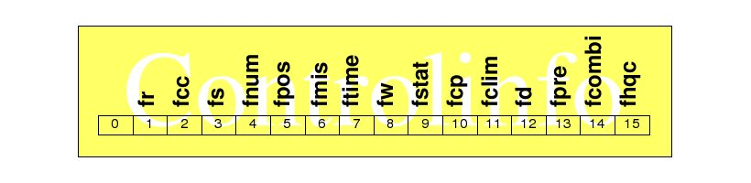
Qc2 flags are already defined in the original kvalobs flag documentation with: controlinfo(7) ftime; controlinfo(8) fw; controlinfo(9) fstat; controlinfo(11) fclim; and controlinfo(12) fd; assigned completely or partly for Qc2. Corresponding specification for the behaviour of useinfo flags also exists but since there has not yet been Qc2 tests in operation there has been little testing of the setings. ]
This space in the Wiki is to analyse the current setup, discuss the flag specification and finalise the Qc2 flag specification, proposing modifications to the whole flag configuration as required.
- Analysis and Discussion
- Specification ... working definitons, not yet official
- ...

