QC1-9 Combined assessment
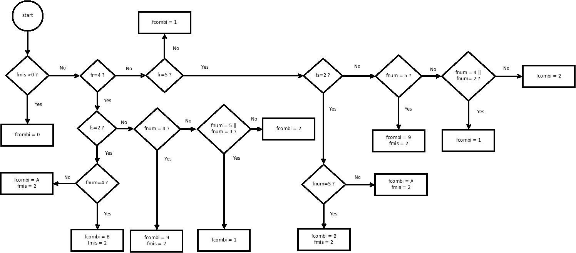
Figure 1: The algorithm applied to PP and TA. With hourly observations the fcombi flag is also set on TAN and TAX.

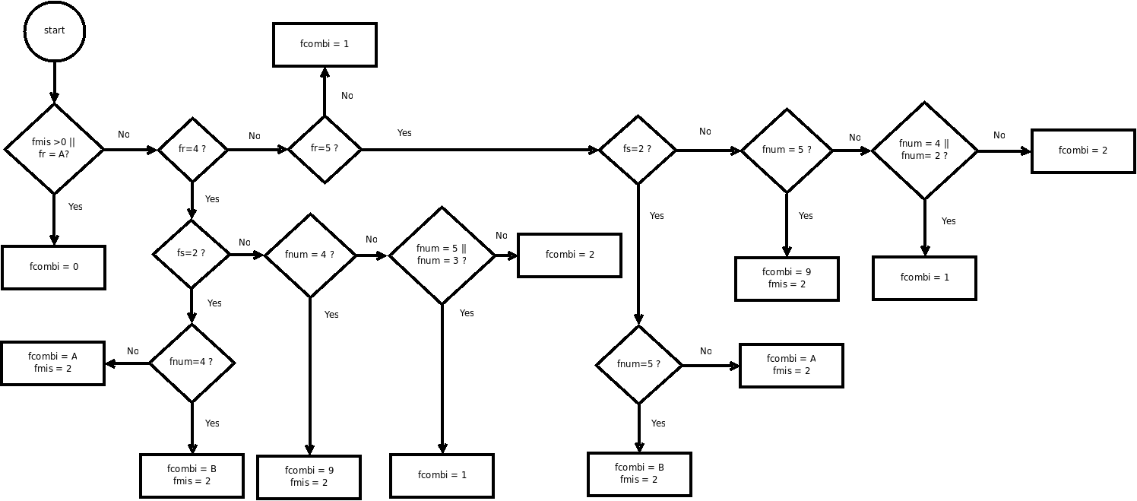UU
Figure 2: The algorithm applied to UU

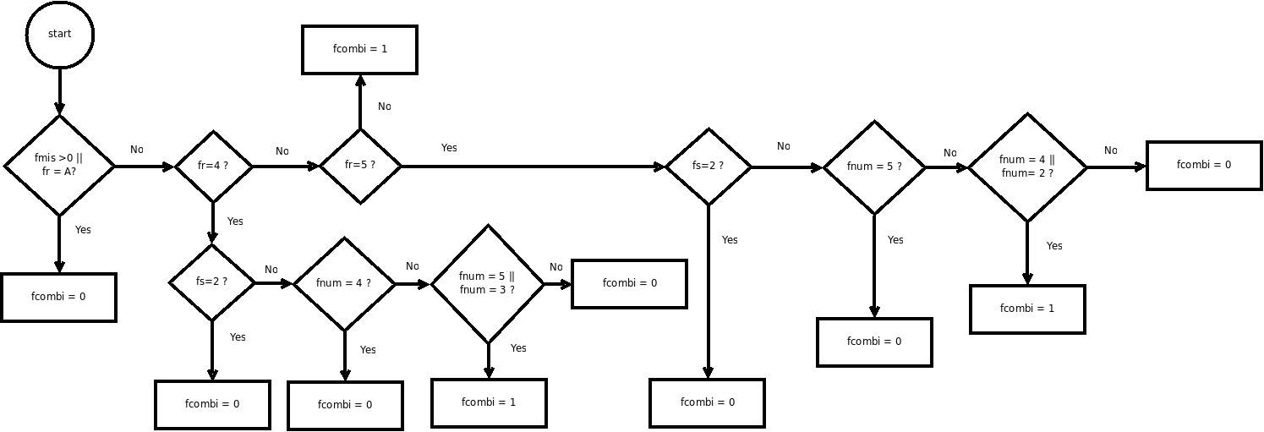
Figure 3: The algorithm applied to FF

- fmis - flag on missing observation
- fr - flag on range control (QC1-1)
- fs - flag on step control (QC1-3)
- fnum - flag on numerical control (QC1-4)
- fcombi - flag on combined assessment

