FIMEX
Description
Features
License
Download
Installation
Usage Examples
Documentation
Support
Frequently Asked Questions
Roadmap
Contact details
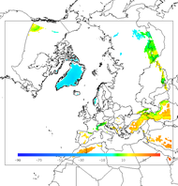 Temperature above 1000m

