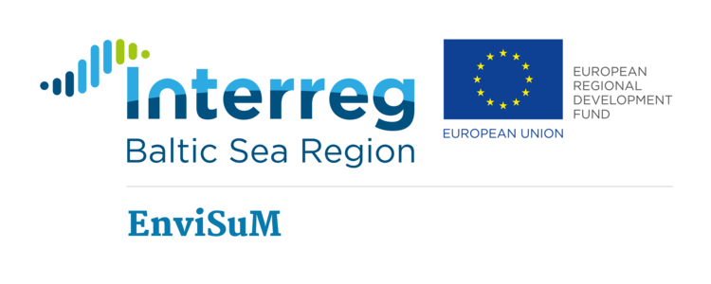
The European Union (European Regional Development Fund) has funded this project studying technical efficiency and socio-economic impacts of clean shipping solutions. EnviSuM is coordinated by the University of Turku.
MET Norway's role in this project is to model air pollution and depositions for 2014 and 2016, to assess the effect of the new IMO regulations on sulfur content in ship fuel (which went into force in 2015). In addition, air pollution and depositions for different future scenarios, assuming different degrees of implementation of emission abatement technologies, will be calculated.
More information can be found at the EnviSum web page at: https://www.utu.fi/fi/yksikot/mkk/hankkeet/envisum/Sivut/home.aspx
Publications: So far, MET Norway has given internal lectures on air pollution modelling and monitoring at the EnviSum kick-off meeting in March 2016 and at the partner meeting in October 2016.

