S9.2.6 - Marine security in the Levantine Basin

Description
The marine security for the Eastern Mediterranean Levantine Basin is based on the MEDSLIK oil drift model, that is operational at the Cyprus Oceanography Center (OC-UCY). Within ECOOP the focus is to show the ability of the MEDSLIK system to provide to the response agencies reliable operational oil spill predictions, particularly through:
- high and low resolution/frequency ocean and wind forcing to enable ensemble forecasts
- response to warning reports for potential and real oil spills

Users
Key users are the
- Subregional Contingency plan for emergency response to major pollution incidents in the Eastern Mediterranean Levantine, between Cyprus, Egypt and Israel and thecorresponding contingency plan for Syria.
- The key users for search and rescue module are the local Search and Rescue centres.

Demonstration
MEDSLIK recently developments include:
- the wave-oil interaction in the oil drift service, where MEDSLIK use the CYCOFOS wave forecasting data.
- backtracking oil drift
- integration with the Cyprus AIS covering the Eastern Mediterranean Levantine basin
- integration with EMSA CSN satellite images
- automatic version of MEDSLIK for 24h forward and backward oil slicks predictions using EMSA CSN ASAR & RADASAR images in the Eastern Mediterranean Levantine Basin (Figure 1)
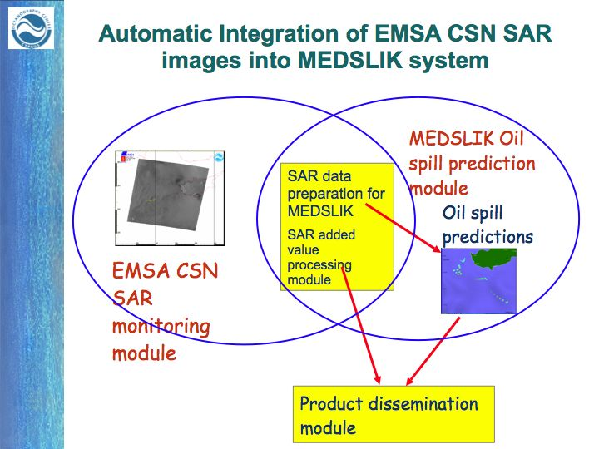
In Figure 2a we display five oil slicks as were identified by EMSA CSN on the 14 January 2009 in the Levantine, west Cyprus. In Figure 2b,c forward and backward predictions of the five oil slicks on 14 Jan. 2009. In Figure 2b the oil spill predictions in the MEDSLIK visualization module, in Figure 2c the MEDSLIK predictions in geotiff image, where red color: forward predictions, green color : backward predictions, yellow color : satellite observation. The predicted slicks in this application were drawn every 12h, using as forcing the CYCOFOS currents and waves and the SKIRON winds.
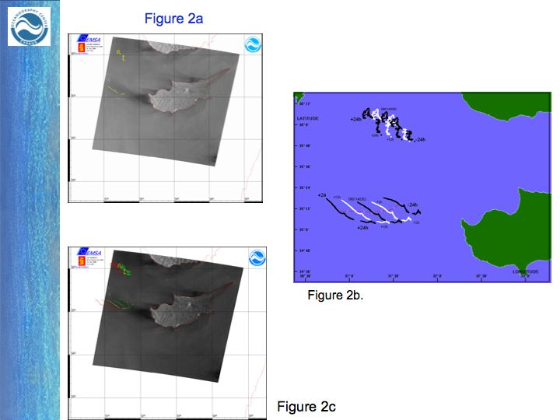
In Figure 3, use of Google Map for visualization of MEDSLIK 24 h forward and backward predictions of the five oil slicks identified by EMSA CSN on the 14 Jan. 2009. red color: forward, green color : backward, yellow: satellite observation. The slicks here were drawn every 6 h, using as forcing the CYCOFOS currents and waves and the SKIRON winds.
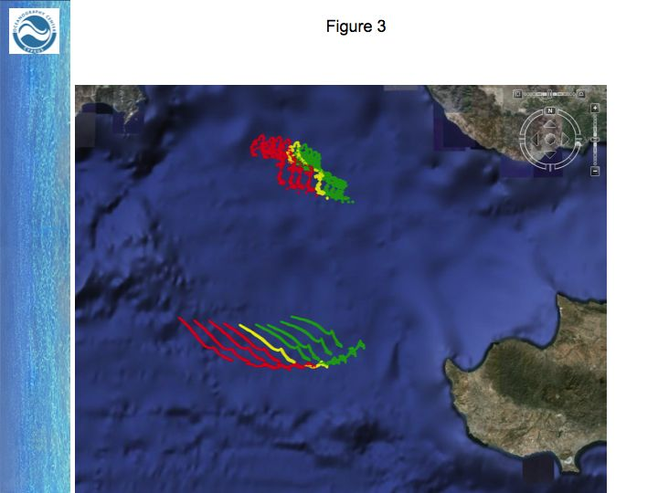
In Figure 4 zoom in the target area of the MEDSLIK 24 h forward and backward predictions of the five oil slicks identified by EMSA CSN on the 14 Jan. 2009.
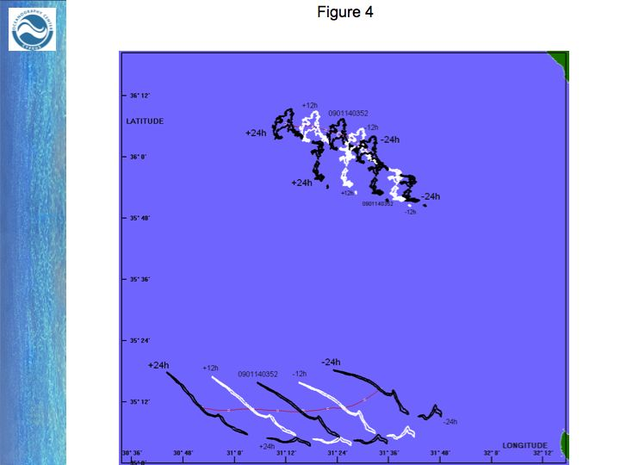
Figure 5a and 5b


