Installing Diana from Launchpad
For users of Ubuntu, it might be easiest to install the pre-built packages for Diana and other software from MET Norway from the MET Norway metapps PPA.
General installation instructions are given under Adding this PPA to your system and Read about installing.

Installation Summary
You need to be able to run the sudo command to be able to install Diana packages (or any other packages).
sudo apt-get install python-software-properties
sudo apt-add-repository ppa:heiko-klein/fimex
sudo apt-add-repository ppa:met-norway/metapps
sudo apt-get update
sudo apt-get install diana-3.39 diana-3.40 ...
The version numbers might, of course, change over time.

First Test
Assuming that you installed diana-3.39, you might want to test that Diana is installed correctly by running it:
diana.bin-3.39 -s /etc/diana/3.39/diana.setup
This should cause a window to open that looks like this, although the map might be missing:
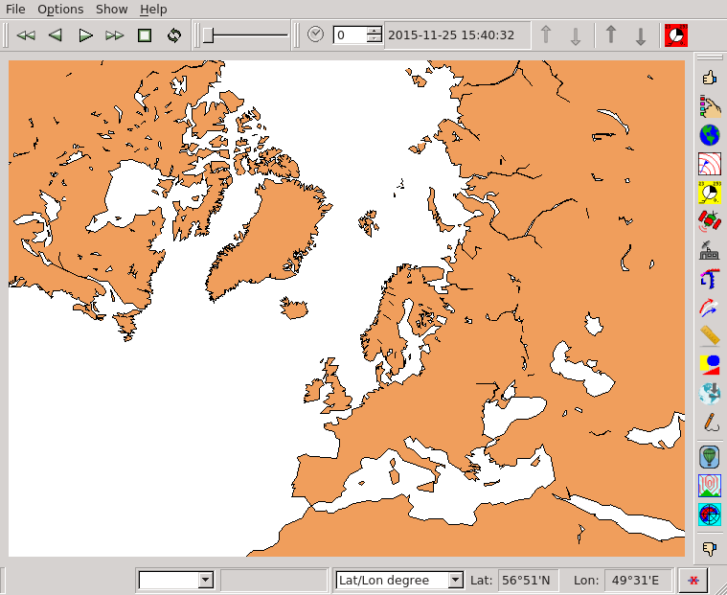
Now you need to configure Diana for your workstation by editing/writing a diana.setup file.

