CityZen Home
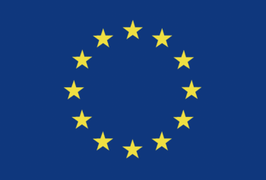

Introduction
CityZen was a 3-year research project focusing on megacities and emission hot spots. Project period: September 2008 - August 2011.
It was funded by the European Commission through Framework Programme 7.

Coordinator
Michael Gauss
Norwegian Meteorological Institute
P.O.Box 43 Blindern
0313 Oslo, Norway

Executive officer
Per Helmer Skaali
Norwegian Meteorological Institute
P.O.Box 43 Blindern
0313 Oslo, Norway

EC Scientific Officer
José M. Jimenez Mingo
European Commission - Research Directorate General (RTD)
Environment Directorate
Unit I.5 - Climate Change and Environmental Risks
1049 Brussels, Belgium

The partners of CityZen
Partner No. | Partner Name | Short Name | Country
1 | Meteorologisk institutt | metno | Norway
2 | Peking University | PKU | China
3 | Centre National de la Recherche Scientifique | CNRS | France
4 | Institut National de l'Environnement Industriel et des Risques | INERIS | France
5 | Universität Bremen | IUP-UB | Germany
6 | Rhenish Institute for Environmental Research at the University of Cologne | FRIUUK | Germany
7 | Forschungszentrum Jülich GmbH | FZJ | Germany
8 | University of Crete | ECPL | Greece
9 | Consiglio Nazionale Delle Ricerche | CNR | Italy
10 | Norsk Institutt for Luftforskning | NILU | Norway
11 | Universitetet i Oslo | UiO | Norway
12 | Institute of Marine Sciences-Middle East Technical University | METU | Turkey
13 | University of Leicester | ULeic | United Kingdom
14 | International Institute for Applied Systems Analysis | IIASA | Austria
15 | National Observatory of Athens | NOA | Greece
16 | Cairo University Center for Environmental Hazard Mitigation | CEHM | Egypt

Short presentations
Click here for a short overview of the CityZen project.
Click here to download the CityZen brochure.
Further information is available from the menu on the left.

Disclaimer
This website does not represent the opinion of the European Union or any of participating institutions, nor is the European Union or any of the participating institutions responsible for any use that might be made of the data appearing herein. Coordinator: Michael Gauss, responsible for this website: Michael Gauss, met.no.

