Joint meeting with MEGAPOLI and MILAGRO

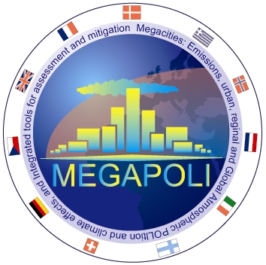|
|

Information
This second, informal meeting between CityZen and its sister project MEGAPOLI took place in Vienna on 4 May 2010 from 10h30 - 12h00 and was intended for those who where present at the EGU General Assembly. The meeting also included the MILAGRO project.
16 participants from MEGAPOLI, 16 from CityZen, 7 from MILAGRO, and 4 from other projects were present at the meeting:
List of participants, kindly provided by Alexander Mahura (DMI, MEGAPOLI).

Presentations
Michael Gauss, met.no, meeting introduction
Alexander Baklanov, DMI, status of MEGAPOLI
Luisa Molina, MIT, poster presentation of MILAGRO
Michael Gauss, met.no, status of CityZen

Minutes
Summary of the meeting, kindly provided by Alexander Mahura (DMI, MEGAPOLI).

