First joint meeting with MEGAPOLI in Vienna, April 21, 2009

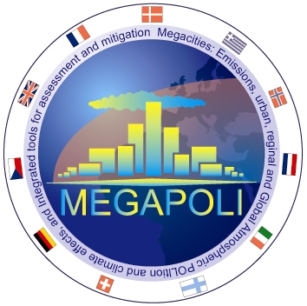|

Information
This first, informal meeting between CityZen and its sister project MEGAPOLI took place in Vienna on 21 Apr 2009 from 10h30 - 12h00 and was intended for those who where present at the EGU General Assembly.

Presentations
Michael Gauss, met.no, meeting introduction
Alexander Baklanov, DMI, overview of MEGAPOLI
Michael Gauss, met.no, overview of CityZen

Minutes
Summary of the meeting, kindly provided by Alexander Mahura (DMI, MEGAPOLI).

