Second joint meeting with MEGAPOLI in Vienna, May 4, 2010

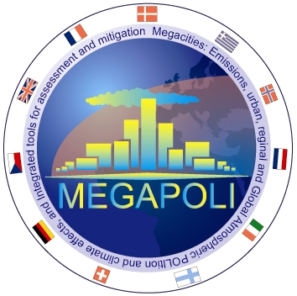|
|

Information
This second, informal meeting between CityZen and its sister project MEGAPOLI took place in Vienna on 4 May 2010 from 10h30 - 12h00 and was intended for those who where present at the EGU General Assembly. The meeting also included the MILAGRO project.

Presentations
Michael Gauss, met.no, meeting introduction
Alexander Baklanov, DMI, overview of MEGAPOLI
Michael Gauss, met.no, overview of CityZen

Minutes
Kindly provided by Dr Alexander Mahura (DMI, MEGAPOLI)
Summary of the meeting, kindly provided by Alexander Mahura (DMI, MEGAPOLI).

