AirQuip
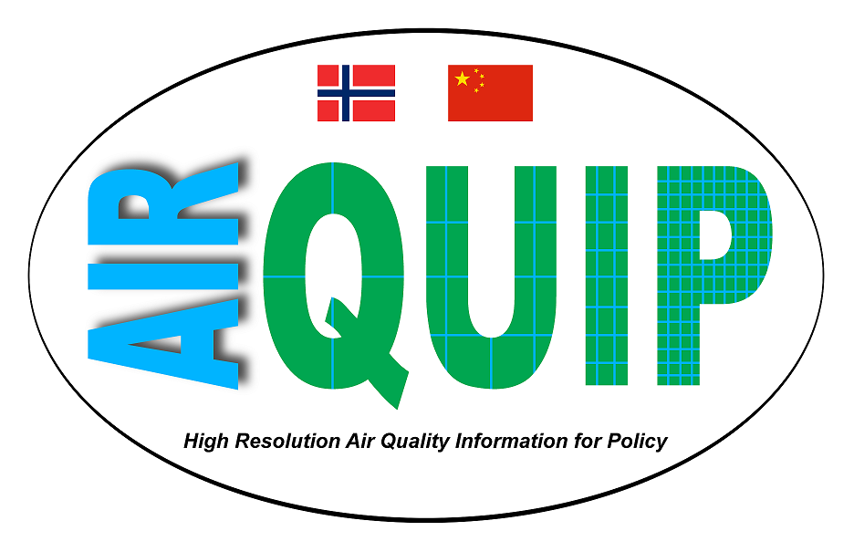
AIRQUIP was funded by the Research Council of Norway to develop a new method for downscaling of regional Air Quality data in collaboration between Norway and China. The Norwegian Meteorological Institute coordinated AIRQUIP, and the partners were: Norwegian Computing Center (Oslo, Norway), Jinan University (Guangzhou, China), and Tsinghua University (Beijing, China).
The project started on 1 March 2017 and lasted for 3 years until 29 February 2020. The kick-off meeting took place in Oslo on 19/20 April 2017.

