Examples of annual assessment maps using uEMEP
Examples of Annual mean NO2 maps using uEMEP downscaling for traffic and shipping.

NO2: Oslo region 2015 (100 m)
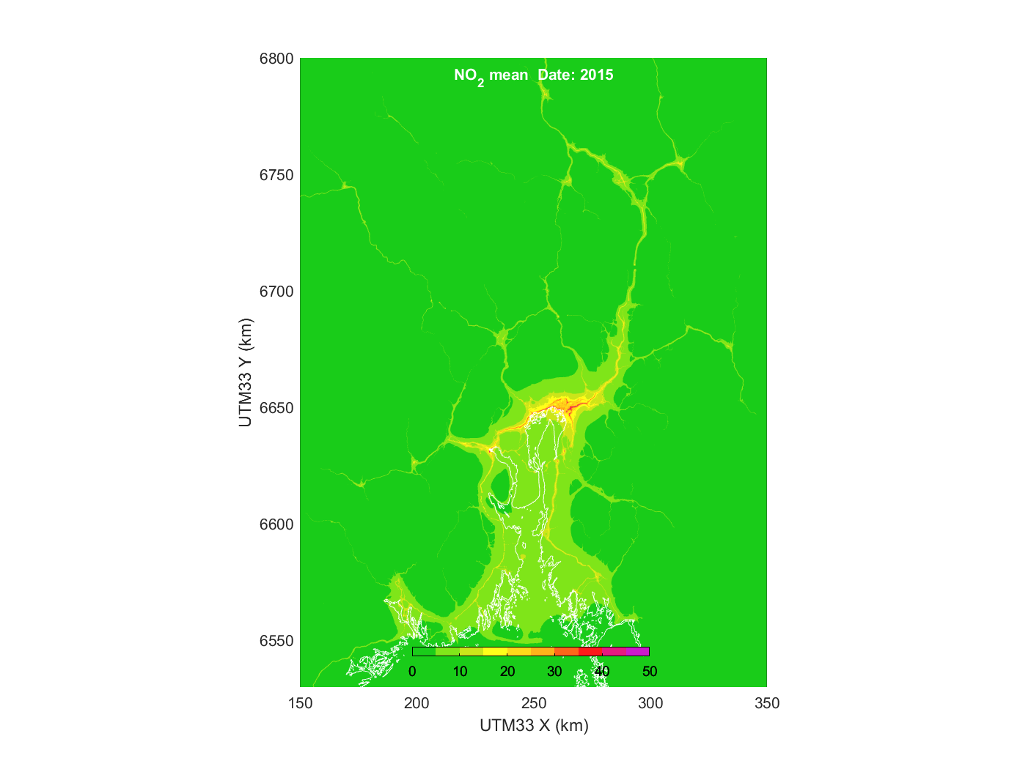

NO2: Hamar 2015 (25 m)


