Global modeling and analysis of aerosol composition, distribution, and new particle formation processes with observations from Atmospheric Tomography Mission (ATom, NASA EVS2, 2016-2020)

Huisheng Bian (UMBC and NASA GSFC)
Christina Williamson (CU Boulder and NOAA ESRL)
Mian Chin (NASA GSFC)

1. Rationale

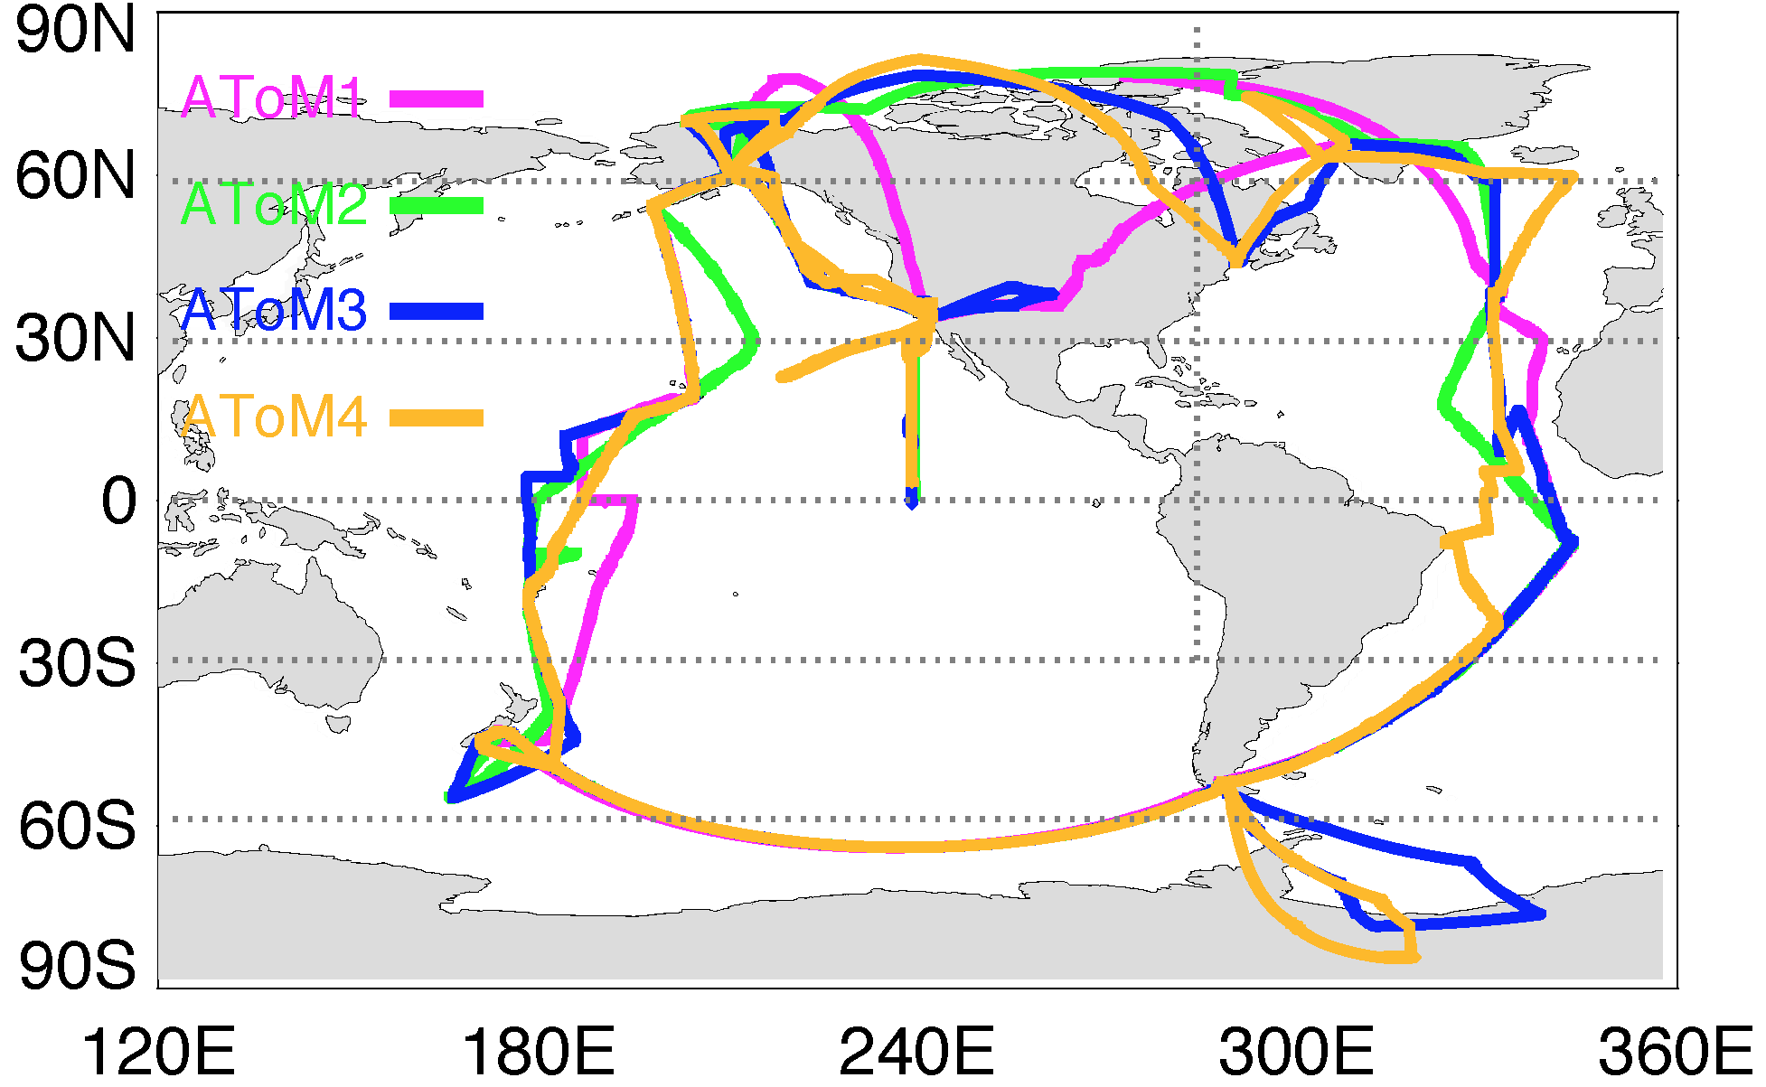
Figure 1. ATom flight routes for four 30-day deployments of the NASA DC-8 in four different seasons in 2016-2018.
The Atmospheric Tomography Mission (ATom) is a NASA-funded Earth Venture-suborbital project to study the impact of air pollution on chemically reactive gases, aerosols, and greenhouse gases in the atmosphere. ATom deploys an extensive gas and aerosol payload on the NASA DC-8 aircraft for systematic, global-scale sampling of the atmosphere, profiling continuously from 0.2 to 12 km altitude. Flights will occur in each of 4 seasons over a 4-year period (starting 2016) with flight routes over the Pacific, Atlantic, Southern Ocean, North America and Greenland from 85°N to 65°S (see Fig. 1 for planned flight route) to establish a comprehensive, global-scale data set. ATom fills aerosol observational gaps over the oceans, providing: (i) single-particle measurements of BC mass, size and coatings; (ii) aerosol size distributions from 0.004 μm through 50 μm diameter, spanning newly formed, CCN-active, and larger particles; (iii) organic and inorganic aerosol composition data; and (iv) gas-phase tracer measurements to provide source and transport information. Table 1 lists the relevant species measured in ATom. Such a comprehensive global data set provides an unprecedented opportunity for global aerosol models to evaluate the transport, chemistry, sources, removal parameters, chemical aging process, and particle activation and growth represented in their models, and to assess human influence on atmospheric composition and cloud properties over remote oceans.

We would like to propose an AeroCom aerosol modeling activity to work with the ATom team interactively on model evaluation and data analysis. Building upon the previous fruitful collaborations between AeroCom and HIPPO (HIAPER Pole-to-Pole, a precursor mission of ATom) on model intercomparison and evaluation (e.g., Schwarz et al., 2010; Samset et al., 2014), we foresee a more productive collaboration between AeroCom and ATom. The science questions, model setup and simulations, and required output fields are listed in the next sections.

2. Science questions

- What are the distributions of aerosols and precursor gases in the remote areas measured in ATom and simulated by models?
- What are the sources (anthropogenic, natural, transported from land, emitted from ocean) of aerosols in the remote areas?
- How do chemistry, transport, and removal processes determine the composition and vertical distributions of aerosols in different seasons and locations?
- What are the sources of new particles in the remote marine boundary layer (MPBL) and free troposphere, how rapidly do they grow to Cloud Condensation Nuclei (CCN)-active sizes, and how well are these processes represented in models?
- How to improve the processes in models to best represent the ATom observations?

Table 1. ATom measurements related to the proposed modeling and analysis activity.
Species | Instrument
Aerosol composition and microphysics:
Particle distribution (4-1000 nm) | AMP
Cloud droplet size distribution (2-50 μm) | AMP
BC mass concentration and coating state | SP2
SO₄^{2–}, NO₃–, NH₄⁺, Cl– | HR-AMS
OA, particle O/C, H/C, and OM/OC ratio | HR-AMS
Single particle composition (200-4000 nm), particle type fractions for SO₄^{2–}/OA/ NO₃–, EC, sea salt, dust, biomass burning | PALMS
Particle type volume concentration | PALMS
MSA/ SO₄^{2–} ratio | PALMS
SO₄^{2–}, NO₃–, NH₄⁺, Cl–, Na⁺, Ca²⁺, K⁺, Mg²⁻ | SAGA filters
⁷Be, ²¹⁰Pb | SAGA filters
Precursor gases and related species:
SO₂ | CIT-CIMS
DMS | WAS, TOGA
OCS | WAS, PANTHER, PFP
CO | HTS, PANTHER/UCATS
CO₂ | HTS
Other:
Pressure, temperature, winds, turbulence | MMS
Spectrally-resolved actinic flux (280-650 nm) | CAFS

3. Planned model experiments

We will have two-level studies of atmospheric aerosols: 1). general aerosol composition, distribution, and processes (ATom-general), and 2). Atmospheric new particle formation processes (ATom-NPF). All AeroCom models are welcome to participate in the ATom-general. Those models, which have capability of aerosol microphysics simulation, are welcome to participate in the ATom-NPF as well.
In ATom-NPF, the occurrence of NPF and influence of this on CCN number concentrations in the model ensemble will be evaluated and compared with ATom measurements. We will compare the location, number and seasonal dependence of nucleation mode aerosols, Aitken and accumulation mode number concentrations and composition where they can be linked to growth of newly formed particles. The influence of factors such as condensation and coagulation sinks, convective influence, anthropogenic and continental influence and marine influence on new particle formation will be investigated. Hemispheric differences, as well as differences between the Pacific and Atlantic will be examined. Where possible, the influence of different NPF mechanisms (e.g. ion-induced, ternary, organics) within a model will be investigated, as well as the influence of free tropospheric nucleation on boundary layer CCN number concentrations (sensitivity studies are detail in the documents linked below. Systematic differences between modal and section aerosol microphysical models will be examined. Advances in the AeroCom ensemble relating to NPF from those published in Mann, Carslaw [1] will be investigated.

Here is our planned model setup and experiments for both ATom-general and ATom-NPF. The Base simulation covers three years of 2016-2018, i.e., the whole ATom observation time period. All other experiments run for one year of 2017 only. All participant models shall use or nudge meteorological data for the simulation period. Please allow 6-month spin up for the baseline simulation. All models use the same pre-defined emission data for gas and aerosol tracers as could as possible.

Emissions:
- Anthropogenic: Coupled Model Intercomparison Project version 6 (CMIP6)
- Biomass burning: Near real time emission (e.g., The Global Fire Assimilation System (GFAS), Fire Energetics and Emissions Research (FEERv1.0-G1.2))
- Volcanic: Carn et al. (2017) if available for ATom time period. Otherwise degassing only
- DMS: DMS sea surface water concentration from Lana et al., 2011
- Ocean POA: report marine POA emission used in your model
- Dust and sea salt: calculated in your model
- Report any other marine inorganic and organic emission used in your mode
- SOA: report SOA production used in your model

Model experiments:
ATom-general:
- Base – all emissions
- ExpA – no anthropogenic emissions
- ExpB – no biomass burning emission
- ExpC – ocean emission only (optional)

ATom-NPF
- Base
- ExpNuc - Free tropospheric aerosol nucleation switched off
- ExpSO2 - Anthropogenic SO₂ emissions switched off
- ExpIon, ExpTer, ExpOrg - If your nucleation scheme includes multiple elements (e.g. ion-induced, ternary, organic), swithching each of these elements off

Document:
Model documentation should include a brief description of the model and any references (limit: one page).

Model output:
Please refer AeroCom III-ATom output specifications for detailed requirements (https://docs.google.com/spreadsheets/d/1EaZO6_FEH6nDhWKE9PvUNpfVkU9RdR2ZT6ahLL2VVEo/edit?usp=sharing).

4. Timetable (tentative)

10.2018 – discuss and refine the experiment plan at the AeroCom meeting
12.2018 – finalize the experiment plan and send it to the AeroCom group
06.2019 - submit model results to AeroCom server
09.2019 – preliminary results for the annual AeroCom meeting
12.2019 – drafts circulated among co-authors
05.2019 – Submission of manuscripts

5. Themes of data analysis

ATom-general:
- Origin of aerosols in continental outflow and remote ocean regions (for example, fraction of aerosols along the ATom track from anthropogenic, biomass burning, and natural sources from BASE, ExpA, and ExpB)
- Atmospheric sulfur cycle; natural vs. anthropogenic sources of nss-SO₄²⁻ over the Pacific, Atlantic, and Southern Ocean (for example, anthropogenic fraction derived from BASE and ExpA and from MSA/nss-SO₄²⁻ ratio, land vs. oceanic origin from BASE and ExpC)
- Vertical profiles of BC, OA, SO₄²⁻, NH₄⁺, NO₃⁻, and dust – evaluating and constraining model removal processes (for example, wet removal processes, convective outflow, aging and mixing, heterogeneous chemistry)
- Maritime aerosol – composition and origins in different regions and seasons

ATom-NPF:
- Regional comparisons of vertical profiles of nucleation, aitken, accumulation and coarse mode particles, and coagulation/condensation sinks to asses representation of production, transport and loss of particles
- Regional comparisons of seasonal trends in nucleation mode and larger particle concentrations
- Assessment of the role different nucleation mechanisms in reproducing feature such as new particle formation in the tropics, polar regions and marine boundary layer
- Study of any systematic differences between modal and section aerosol microphysical representations, and how this affects reproduction of ATom measurements

References:
Mann, G.W., et al., Intercomparison and evaluation of global aerosol microphysical properties among AeroCom models of a range of complexity. Atmospheric Chemistry and Physics, 2014. 14(9): p. 4679-4713.

